**ABOUT THE SYSTEM**

**NDOTO AJIRA**

Ndoto Ajira Management System (NAMS) is the web based system that is developed for automating Ndoto Ajira Organization’s activities, this system can be accessed through the organization and outside as well as with proper login provided. This system can be used as online system to manage the applicant informations when they make application for Ndoto Ajira’s competition by applying either individual or group to show their talents, dream and innovation. Applicants logging should be able to upload their information as well as their idea and description to show what do their ideas mean.

## **Problem statement**

## 

There has been various problems during the existing of current system because all their operations were done manually and leaded lost of money, wasting time when operating their activities, not only this but also loosing of data, also data retrieval were not easy process. Also the confirmation issue after application were using phone call so they were calling some applicants and they were unreachable at that time.

## **Problems Solution and the scope**

The proposed system will be an automated by developing a computerized system that will able to record the information about their activities both from external to internal of the Organization.

So the proposed system will help Ndoto Ajira Organization and the applicants who made application in data accessibility, updating and even deleting them when not needed. Also the proposed system will help to confirm the applicants online through their accounts after making online application so applicants may look at their confirmation at any time anywhere.

#### Forms and Reports

#### **Registration form sample**

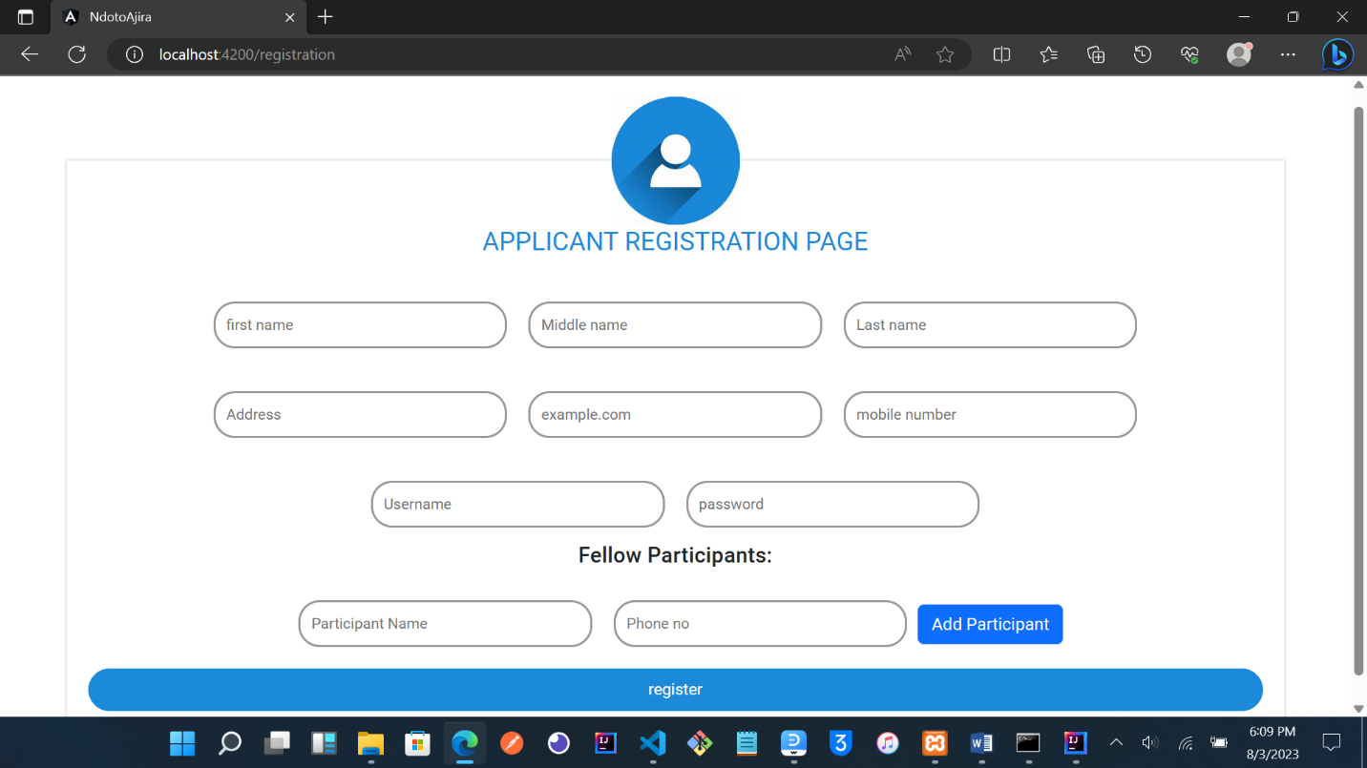

Registration form

Login Form

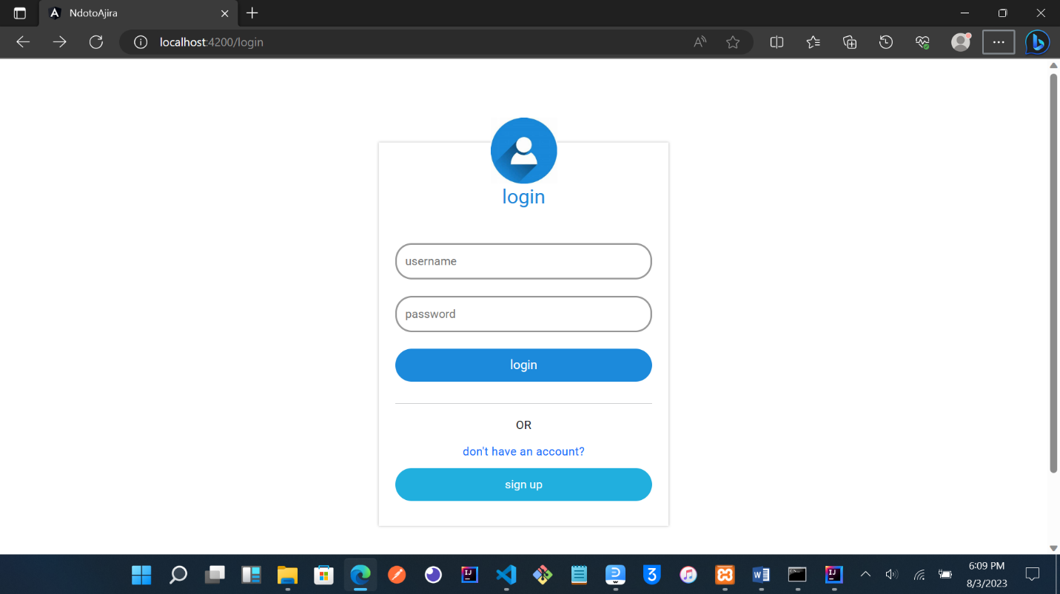

login form

#### **This picture shows the posted competitions by Ndoto ajira Organization**

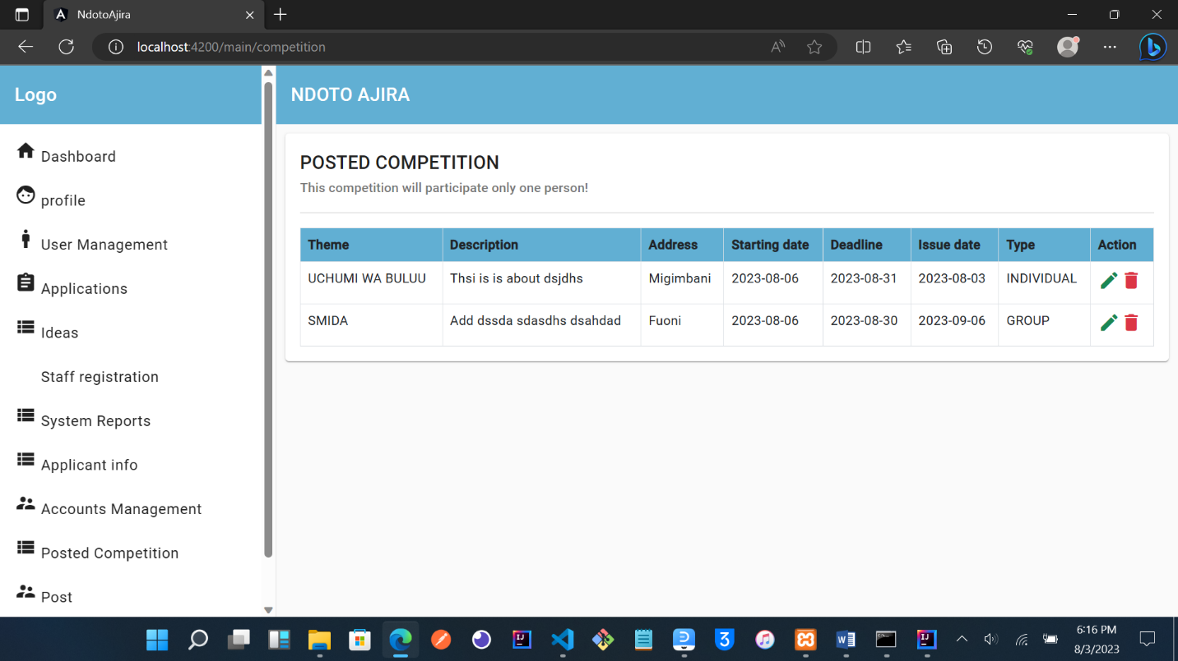

report page

Interface design sample

This picture shows the applications made by the applicant

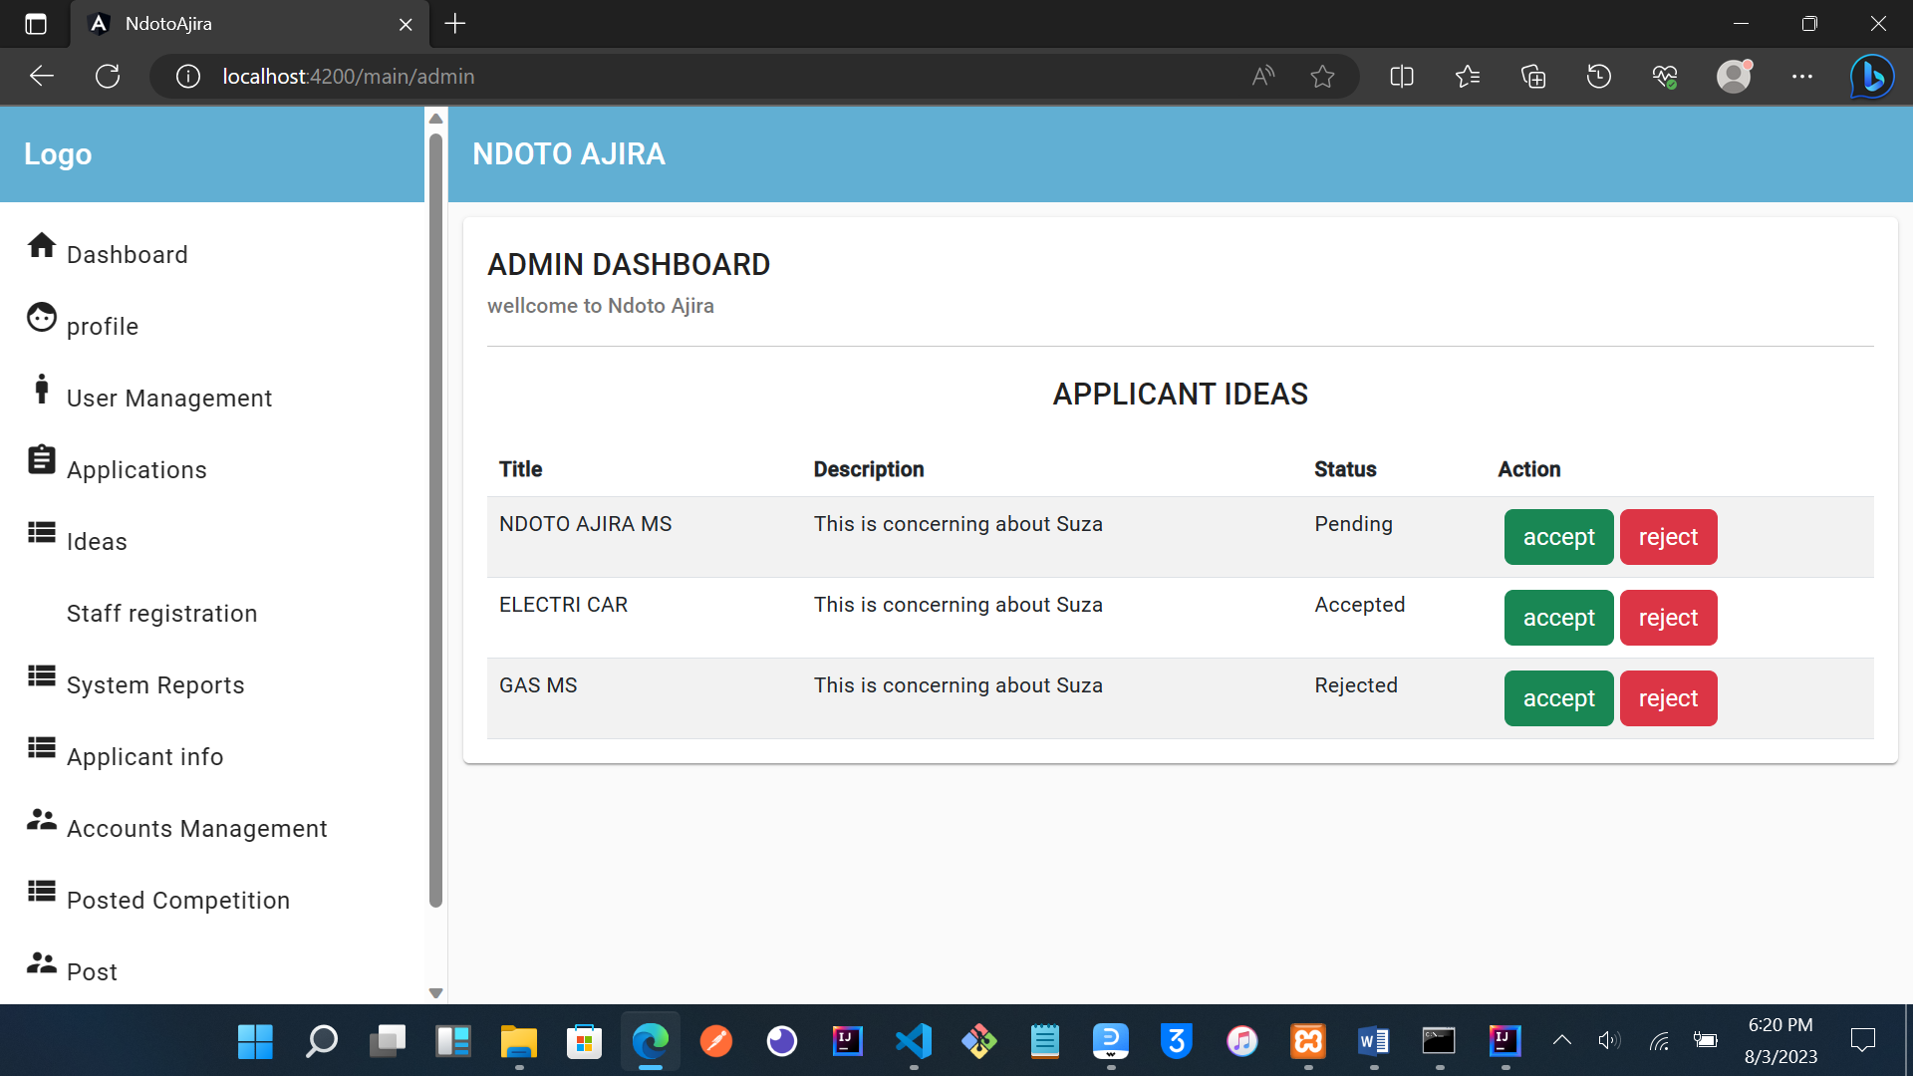

interface design sample